Kajian Fonetik Akustik Mengenai Frekeunsi Kucing Dengkur Antara Umur Berbeza

(The Study Of Acoustic Phonetics On Frequency Cat Snoring Between Different Ages)

# Syed Norman Daniel Bin Syed Mahadir

*Fakulti Sain dan Teknologis, Universiti Kebangsaan Malaysia, 43600 Bangi, Selangor, Malaysia.*

*\*mel-e pengarang rujukan:* [*syeddaniel711@gmail.com,*](mailto:syeddaniel711@gmail.com)[*arifjalil@utm.my*](mailto:arifjalil@utm.my)

**Abstrak:** Kucing berdengkur adalah bunyi yang telah dihasilkan oleh kucing yang dibuat oleh beberapa spesies felids dan dua spesies genet. Kucing domestik (Felis silvestris catus) adalah salah satu haiwan domestik yang paling biasa kita dengari pada masa ini. Kucing ini juga ada ada keistimewaan serta keunikan dia tersendiri diantaranya adalah kucing mampu menghasilkan frekuensi yang sangat rendah dan mampu memberi maanfaat untuk manusia sejagat. (Wereski, Mike 2015). Tujuan pertama untuk mengkaji frekuensi yang telah dihasilkan oleh kedua-dua ekor kucing dan mengenal pasti samada usia kucing itu mempengaruhi frekuensi yang telah dihasilkan. Tujuan kedua adalah Untuk mengenal pasti adakah sikap kucing yang berlainan akan mempengaruhi frekuensi yang dihasilkan oleh kucing. Subjek kajian adalah dua ekor kucing domestik dimana Kucing domestik A, bernama molly adalah seekor kucing betina berumur 4 bulan baka campuran, manakala kucing domestik B, bernama spooky, adalah seekor kucing betina berumur 36 bulan dan kucing domestik C bernama Neslo iaitu kucing betina berusia 17 bulan . Ketiga-tiga subjek kajian adalah baka campuran yang berlainan. Ketiga-tiga kucing itu adalah kucing domestik dimana telah dijaga dan dipelihara dari sejak kecil lagi. Pemilihan ketiga-tiga kucing berdasarkan atas sebab perbezaan usia dan tingkah laku. Perekodan data menggunakan peralatan telefon jenama Iphone SE (2020) dan untuk data frekuensi kucing dikumpulan ketika sedang tidur.Perhasilan bunyi dengkuran kucing domestik yang berusia menghasilkan lebih tinggi berbanding dengkuran kucing domestik yang muda. Kesimpulannya, bunyi juga boleh menjadi semakin lantang seiring bertambahnya usia. Semakin berusia umur kucing itu, semakin tinggi frekuensi yang dihasilkan oleh kucing.

**Kata kunci:** *Frekuensi, dengkuran kucing, kotak suara kucing, fonetik akustik*

**Abstract:** Cat purring is a sound that has been produced by cats made by several species of felids and two species of genetics. The domestic cat (Felis silvestris catus) is one of the most common domestic animals we hear of today. This cat also has its own specialties and uniqueness, among them is that the cat is able to produce very low frequencies and is able to provide benefits to all humans. (Wereski, Mike 2015). The first purpose was to study the frequencies that had been produced by both cats and to identify whether the age of the cats influenced the frequencies that had been produced. The second purpose was To identify whether different cat attitudes would influence the frequency produced by cats. The study subjects were two domestic cats where Domestic Cat A, named molly was a 4 -month -old female cat of mixed breed, while domestic cat B, named spooky, was a 36 -month -old female cat and domestic cat C named Neslo which was 17-month-old female cat.. The two study subjects were different mixed breeds. Both cats are domestic cats which have been cared for and cared for since childhood. The selection of the two cats was based on reasons for differences in age and behavior. Data recording using Iphone SE (2020) brand telephone equipment and for cat frequency data were collected while sleeping. This aims to collect standard cat vocalizations. The purs sound production of older domestic cats is higher than that of young domestic cats. In conclusion, sound can also become louder as the age. The older the cat is, the higher the frequency the cat produces.

**Keywords:** *Frequency, cat purring, cat voice box, acoustic phonetic*

# Introduction/Pengenalan

# *1.0 Introduction/Pengenalan*

The cat is a pet that has always been kept by humans and its scientific name is Felis catus. This is a small animal that belongs to the "Felid" family. Cats are the only family species domesticated. Cats are animals that are loved and cherished by many people in the world. They love to play and spend time with them reducing stress and anxiety.Pets of domestic cats are a source of fun and excitement. Most children and adults are very fond of keeping these domestic cats as pets. Pets help a person to achieve a healthy state of mind and playing with our pets makes us happy. Cats are beautiful little animals resembling tigers. It lives on the streets as well as in our homes and is one of our favorite pets. The cat’s body is covered with soft and silky hair and has four short legs and sharp claws hidden in a fleshy liner. This cat also has its own specialties and uniqueness, among them is that the cat is able to produce very low frequencies and is able to provide benefits for all humans (Wereski, Mike 2015).

When a domestic cat produces a snoring sound, the snoring sound produces a frequency, amplitude and waveform based on the strength of the snoring sound. A sound wave is like any other wave in that it is carried to the medium by a vibrating object. Sound is a mechanical wave produced from the alternating vibrations of medium particles through which sound waves travel. If a sound wave moves from left to right through the air, then the air particles will be moved to the right and to the left as the energy of the sound wave passes through it. Figure 1.1 characterizes sound waves in air as longitudinal waves.

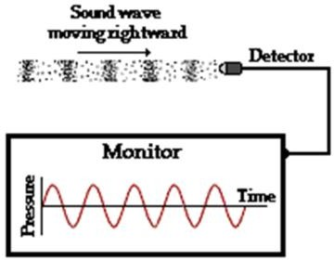

Figure 1.1, sound waves propagate in the air and pass through to the sound detector

* 1. *Objective / Objektif*

● To investigate the snoring voice domestic cat are they is in the range of 25 Hz until 150 Hz

● To investigate the frequency of snoring domestic cat by using Discrete Fourier Transform

● To identify either, different behavior can produce different frequencies.

## Material and Method / Bahan dan Kaedah

* 1. *Liteture review* */ Kajian Literatur*

Cat snoring is a sound that has been produced by cats made by several species of felids and two species of genetics. The domestic cat (Felis silvestris catus) is one of the most common domestic animals we hear of today. This cat also has its specialties and uniqueness, among them is that the cat can produce very low frequencies and can provide benefits to humans. (Wereski, Mike 2015). Cat snoring is a sound produced by a cat from several species of felids and two species of genetics. Domestic cats (Felis silvestris catus) are one of the most common domestic animals in the human environment.

This cat also has a privilege as well as its uniqueness, among which are capable cats that produce a very low frequency and can give benefits to universal humanity. More recent research shows that the frequency between 20 and 50 Hz increases bone density, (Northcare Physio. 2016). Much research has been done on cat snoring. Among them are sissom et al. (1991), mccombetal (2009), Ekland et al. (2010), Schotz and Eklund (2011), Schotz (2012) as well as Syasha Najihah and Azmin Sham (2018). Recent research shows that cat frequencies between 20 and 50 Hz can increase bone density, (Northcare Physio 2016). The same experiment showed that the same frequency range relaxes tense muscles.

A study by Tavernier, C., Ahmed, S., Albro Houpt, K., & Chan Yeon, S. (2019), found that cats have 20 types of sounds. All cat sounds have different frequencies and have their meanings. Thus, pet cats can establish efficient communication with humans thanks to their vocal flexibility. This review allowed him to make a concise model of the cat’s vocal repertoire

* 1. *Method / Kaedah*

The method and techniques that can be used with study subject domestic cats of different ages and breeds were used as study subjects. The aim was to study frequency vocalization. The experimental period of collecting cat vocalizations took two semesters. Cat frequency data were collected while sleeping because it is much easier to collect the purr voice. This aims to collect standard cat vocalizations and visualization.

A recorder device brand Iphone SE (2020) was used for the recording of the vocalization purr domestic cat which has their own owner. For this method, I have recorded 3 domestic cats which are mostly time their cats spend daily life by sleeping, eating, and playing plus not going outside because of laziness and fear with people surroundings. Different breeds and ages were the main criteria for the selection of cat’s candidate. The recorder device was placed in front of the study subject when sleeping to make sure the data can be secure. The duration of recordings must be 30 seconds above for precautionary purposes.

The Praat analysis has been used to acquire data which can help to analyze, synthesize,

and manipulate the purr recordings. Data will get in term of frequency, spectrogram, pitch, formant and waveform graphs.

Jadual 1 Sifat kucing domestik yang terlibat dalam kajian

|  |  |  |
| --- | --- | --- |
| Molly (Kucing Domestik A) | Spooky (Kucing Domestik B) | Neslo (Kucing Domestik C) |
| * 4 months old * Hyperactive * A lot of time is spent playing from sleep. * Closer to people around | * 3 years old * Not very active * A lot of time is spent sleeping from playing. * Very cowardly with people around. | * 1 years 5 month * Active for sometimes * Sometimes crazy, * noisy, like attention, not afraid of people, do not like other cats |

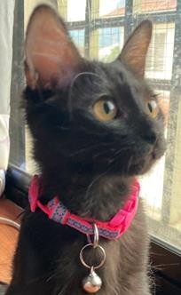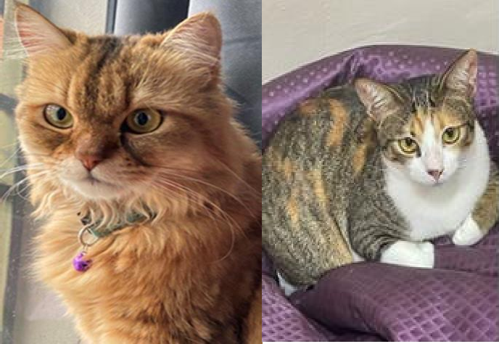

Figure 2.1, Study Subjects, Domestic Cat A, Domestic Cat B and Domestic Cat C is named Molly, Spooky and Neslo.

## Results and Discussion /Hasil dan Perbincangan

* 1. *Cat Snoring Analysis through Praat Analysis Software*

The table below shows the data recorded by domestic cat A (Molly), domestic cat B (Spooky) and domestic cat C (Neslo) during sleep. The data was taken based on the duration of snoring voice of egressive and ingressive phases (inhale and exhale phase). The result below is given the Mean Pitch, Purr range between high and low frequency value (in Hz), Pitch Sigma, Jitter, Shimmer, Mean f0 and HNR for sustained voice.

## Table 2 below shows the data recorded by both domestic cat A (Molly) , domestic cat B (Spooky) and domestic Cat C (Neslo).

|  |  |  |  |
| --- | --- | --- | --- |
|  | Domestic Cat A (Molly) | Domestic Cat B (Spooky) | Domestic Cat C (Neslo) |
| Purr range between high and low frequency value | 30.12 Hz | 26.75 Hz | 8.974 Hz |
| Mean of Purr voice intensity | 46.7694 dB | 53.1263 dB | 42.4332 dB |
| Mean pitch in sustained voice | 98.083 Hz | 85.8193 Hz | 79.1065 Hz |
| Jitter in sustained voice | 7.442% | 9.677% | 8.730% |
| Shimmer in sustained voice | 25.655 % | 17.626% | 42.131% |
| HNR for sustained voice | 3.753 dB | 4.359 dB | 4.131 dB |
| Mean f0 in sustained voice | 79.1047 Hz | 76.6915 Hz | 75.2089 Hz |
| Pitch sigma in sustained voice | 1.229 ST | 1.514 ST | 0.851 ST |

* 1. *Cat snoring Analysis on spectogram, amplitude and Fourier Analysis*

Diagram 3.11, 3.12 and 3.13 below shows the spectrogram graph for domestic cat A, B and C for approximately 10 seconds.

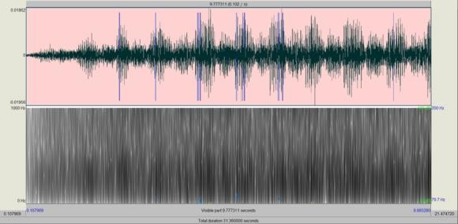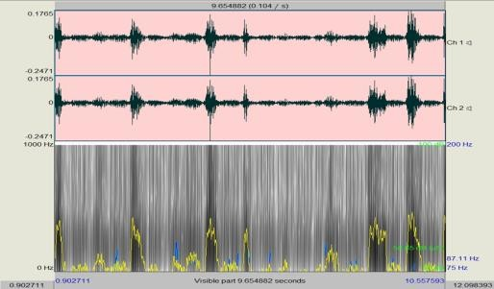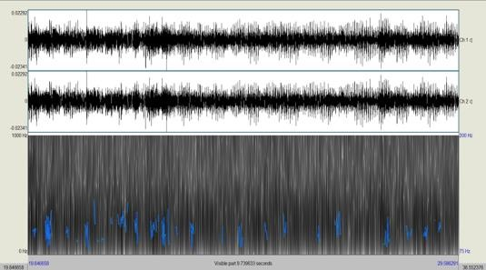

On top the right is spectrogram graph domestic cat A, on top the left is spectrogram graph domestic cat B and below is spectrogram graph domestic cat C.

A spectrogram is a visual way of representing signal strength, or "loudness", signal overtime at a variety of frequencies available in certain waveforms. As can be seen, three of the resulting spectrograms, diagram 3.11, 3.12 and 3.13, respectively have different results. Based on spectrogram domestic cat B (Spooky), it can be seen as more readable than another two diagrams because Spooky has less shimmer on the recordings purr. The shimmer changes with the reduction of glottal resistance and mass lesions on the vocal cords and is correlated with the presence of noise emission and breathiness. ([(João P. Teixeira, Paula O. Fernandes, 2014)]). The loudness depends on intensity, the higher intensity that if can be obtained, the greater the spectrogram can be shown. The diagram 6.22 and 6.23 spectrograms can be seen as having nearly white and black areas which are indicated to egressive and ingressive phases in the duration of 10 seconds.

Diagram 3.21, 3.22 and 3.23 shows the Amplitude graph for domestic cat A, B and C for one phase ( Egressive–Ingressive Phase)

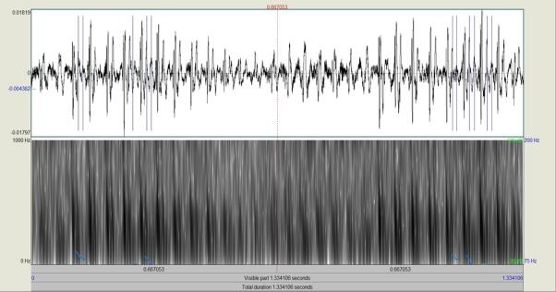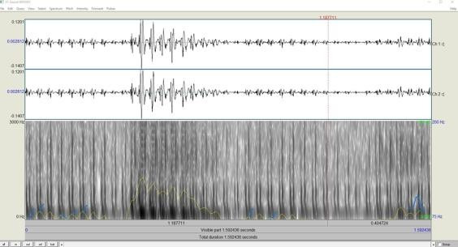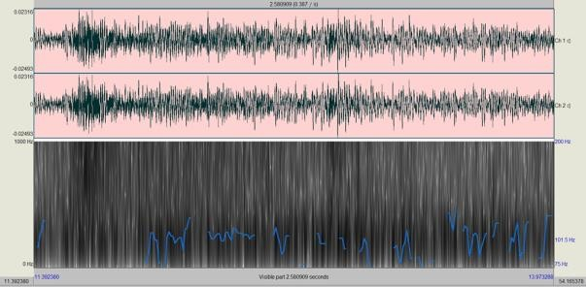

On top the right is amplitude graph domestic cat A, on top the left is ampitude graph domestic cat B and below is amplitude graph domestic cat C.

The scheme above shows the different sizes of amplitudes that indicate those different domestic cats in the one egressive–ingressive phase and the graph is amplitude vs time. Based on both diagram 3.21,3.22 and figure 3.23, cat A produces a lower amplitude compared to domestic cat B and cat C. The study found that there is a relationship between frequency and is increasing the higher the amplitude, the higher the frequency and the loudness produced. This is because the relationship between wavelength and frequency is an inverse relationship, the higher the frequency, the shorter the wavelength. As we can see on table 2, domestic cat B is the highest mean pitch which is frequency followed by cat C and A.

Diagram 3.31, 3.32 and Figure 3.33 shows graph Discrete Fourier Transform for Domestic cat A, Domestic cat B and Domestic cat C.

|  |  |  |
| --- | --- | --- |
|  |  | |
| A graph of a frequency  Description automatically generated  The graph above Discrete Fourier Transform shows frequency domain for three domestic cat. From observation, domestic cat B(Spooky) and C(Neslo) has similar graph compare to domestic cat A. This shows that both cat has consistently produced larger snoring and decrease as value Frequency is increasing. However, The domestic cat A, B and C are to been seen are mostly produced in range 25 until 150 Hz. The graph that has higher peak indicates that, the sound or voices most likely occur in that particular frequency. The higher peak that been recorded for this discrete fourier transform for those three cat which are:  Domestic cat A(Molly) = 99.89922551 Hz  Domestic cat B(Spooky) = 54.04708 Hz  Donestic cat C(Neslo) = 48.97959 Hz   * 1. *Dicussion / Perbincangan*   The study found that the difference in the sound of cat snoring between domestic cat A, cat B and cat C is the production of sound from a box known as the trachea. Animals can make sounds by making vibrations in the vocal cords or folds. This fibrous cable is part of the air space at the top of the trachea or airway known as the larynx or voice box. Vowel folds open and closes the opening of the trachea, producing the characteristic sound of cat snoring. More the more vibrations of the vocal cords are produced, the higher the snoring frequency of the resulting cat.  **4.0 Conclusion / Kesimpulan**  In this thesis, we began to learn the acoustic phonetics which are the study characteristics of speech that include analysis on frequency, intensity and furthermore. For result data quite surprisingly to manage although there are some difficulties to do. The theoretical data and actual data have been compared for this thesis. Below there some conclusion that could be make:  A. From the discrete fourier transform, we can see that the range of actual value for feline and domestic cats is around 25-150 Hz ( Syasha Najihah and Azmin Sham (2018)), and theoretical data (which can be obtained by using Praat Analysis) in the range of actual value for purr voice domestic cats.  B. The discrete fourier transform graph shows the different distribution graph for young domestic cats (Molly) and the middle age domestic cats (Spooky and Neslo) due to different voice box(larynx).  C. The age and larynx of a domestic cat can affect the theoretical result | |

**References / Rujukan**

Eklund, R., Peters, G., Duthie, E. D. 2010, *an acoustic analysis of purring in the cheetah (Acinonyx jubatus) and in the domestic cat (Felis catus)*. Proceedings, FONETIK 2010.Conference Proceedings: 17-22. Lund University, Sweden, Dept. of Phontetics, Centre for Languages and Literature.

McComb, K., Taylor, A. M.,Wilson., C., & Charlton, B. D. 2009.The Cry Embeded within the purr. Current Biology. 19(13).

Northcare Physio. (2016). *Cat purr strengthens our bones*. https://northcare.com.au/blog/cat_purr_strengthens_our_bones/ [28/09/2021]

Schötz, S. & Eklund, R. 2011. *comparative acoustic analysis of purring in four cats. Proceedings of Fonetik* 2011, June 8-June 10. 51. https://www.ida.liu.se/~robek28/pdf/Schotz_Eklund_2011_Purring_DomesticCats.pdf Fonetik 2011 [27 Mei 2018].

Schotz, S. 2012. *A Phonetic Pilot Study of Vocalisations in Three Cats*. Proceedings of XXVth S. P. Co, May 30-June 1. 45-48.

Syasya Najihah Badron Saidi & Azmin Sham Rambely. 2018. *Analisis Dengkuran Kucing Menggunakan Jelmaan Fourier Pantas*. Undergraduate Research Journal for Mathematical Sciences and Data Science, 2: 205 – 212

Tavernier, C., Ahmed, S., Albro Houpt, K., & Chan Yeon, S. (2019). *Rh: cat communication*. Journal of Veterinary Science, 1–13. https://doi.org/10.4142/jvs.2020.21.e18

Wereski, M 2015. The Threshold of Hearing.The STEAM Journal 2(1): Article 20. DOI: 10.5642/steam.20150201.20 Available at: http://scholarship.claremont.edu/steam/vol2/iss1/20

WASHINGTON STATE UNIVERSITY. (2022, January 4). *Cat and dog anatomy*. Veterinary Teaching Hospital. Retrieved June 4, 2022, from https://hospital.vetmed.wsu.edu/2022/01/04/cat- and-dog-anatomy/

Teixeira, J. P., & Fernandes, P. O. (2014). *Jitter, Shimmer and Hnr classification within gender, tones and vowels in healthy voices (thesis)*.

Forrest, T.G. & Suter, R. B. 1994 . *The Discrete Fourier Transform (DFT) in Behavioural Analysis*. Volume 166. Journal of Theoritical Biology.